**THEORY:**

**Learning objective:**

After completing this simulation experiment of Proell governor one should be able to:

1. Define advantage over Porter governor
2. Explain the working of Proell governor
3. Derive governing equation of Proell governor
4. Understand advantage over Porter governor

**Introduction:**

Governors, in general, are most useful means of controlling or regulating the speed of an engine based on varying levels of the load at the output. Though the concept of governors and flywheels are many times misunderstood, both act for a different set of purposes. While the former regulates the speed considering the variations seen in the loading conditions, the latter regulates the speed due to the variations are seen in the engine due to moment fluctuations. Think of the governors from its usefulness. They are used in regulating the speed of the engine, which takes to the fact that the fuel injected is based on the speed variations seen along the shafts

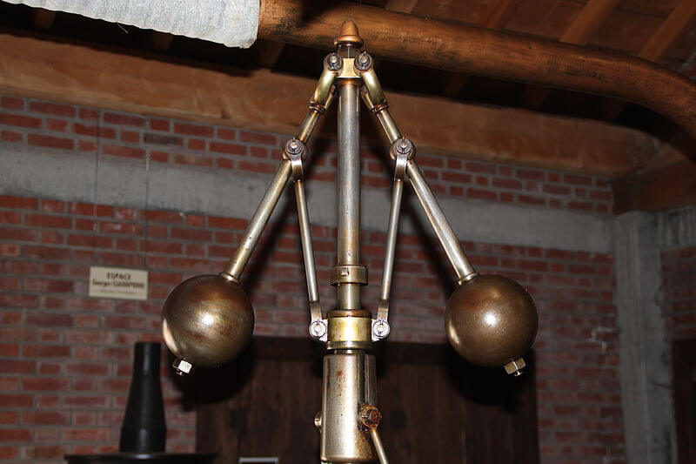

(Ref: https://www.mecholic.com)

Proell governor is a type of gravity controlled [**centrifugal governor**](http://www.mecholic.com/2016/12/types-of-governor-centrifugal-inertia.html#Centrifugal_governor). Its construction is similar to porter governor (It has a central load like in the porter governor). However, in Proell governor, the balls are attached to the extension link. The construction and working of Proell governor similar to porter governor. The only difference is that the governor balls are fixed at the upward extension of links.

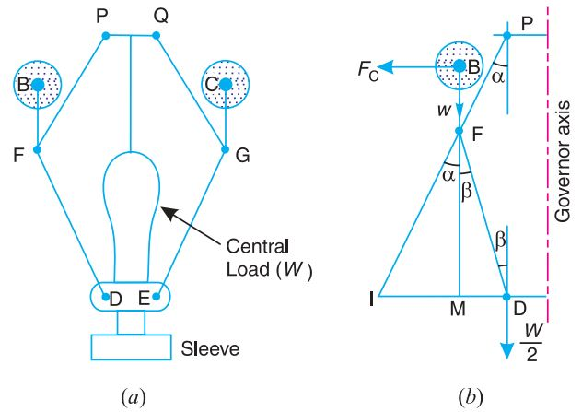

h

Figure 1Proell governor

**Mathematical equation:**

*m* = Mass of each ball (kg)

*W* = Weight of each ball = m*g (N)

*M* = Mass of central load (N)

*r* = Radius of rotation (m)

*h* = Height of governor (m)

*ω* = Angular speed of the ball in (rad/s)

*Fc* = Centrifugal force acting on the ball (N)

*T1* = Tension in the arm (N)

*T2* = Tension in the link (N)

*α* = Angle of inclination of the arm (rad)

*β* = Angle of inclination of the link (rad)

By considering the equilibrium force for half of the governor referring above figure. The instantaneous centre (I) lies on an extension of PF and MD in a leftward direction. BM is drawn a perpendicular to the ID. If we take a moment of inertia through I,

$$F_{c}×BM=w×IM+\frac{W}{2}×ID=mg×IM+\frac{Mg}{2}ID$$

$F_{c}=mg×\frac{IM}{BM}+\frac{Mg}{2}\left(\frac{IM+MP}{BM}\right)$......................... (1)

Where, [ID = IM+MD]

Multiplying and dividing both sides by FM we get,

Fc = $\frac{FM}{BM}\left[m*g*\frac{IM}{FM} + \frac{M*g }{2}(\frac{IM}{FM}+\frac{MP}{FM})\right]$

Fc = $\frac{FM}{BM}$ [m*g $tanα$* + $\frac{M*g }{2}$ ($tanα+tanβ$)]

Fc = $\frac{FM}{BM}* tanα$ [m*g + $\frac{M*g }{2}$ ($1+\frac{tanβ }{tanα}$)]

m $ω^{2}$**r = $\frac{FM}{BM}*\frac{r}{h}$ [m*g + $\frac{M*g }{2}$ ($1+q$)]

Where tanα = $\frac{r}{h}$ and q = $\frac{tanβ }{tanα}$

$ω^{2}=\frac{FM}{BM} \left[\frac{m*g + \frac{M*g }{2} \left(1+q\right)}{m}\right]\frac{g}{h}$....................... (2)

$$N^{2}=\frac{FM}{BM} \left[\frac{m*g + \frac{M*g }{2} \left(1+q\right)}{m}\right]\frac{895}{h}$$

Where, $ω=\frac{2πN}{60}$ and g = 9.81m/s2

When α = β then q = 1

$N^{2}=\frac{FM}{BM}[ \frac{m*g + M}{m}]\frac{895}{h}$......................... (3)

is the required equation.

**Advantages over Porter governor:**

Comparing final equation of Proell (3) with the final equation of the Porter governor, we will see that for a given value of m, M and h equilibrium speed reduces. So for having the same equilibrium speed for m, M and H ball of smaller masses can be used in Proell governor compare to Porter governor.

**Procedure:**

AIM: To visualize the working and effect of speed change through simulation

1) In simulation window side and top view of Proell governor is given.

2) You can see the effect on the governor by changing rotational speed from 100 to 150 rpm.

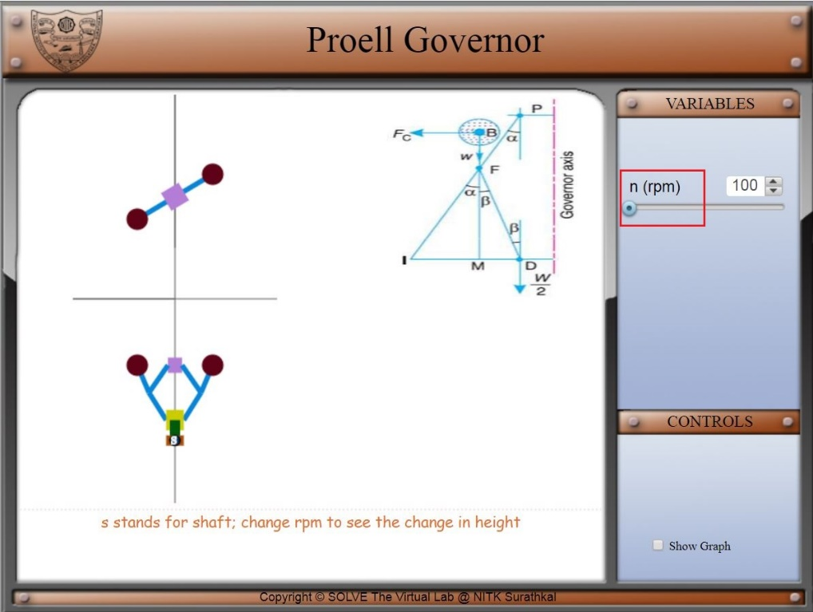

3) Speed control pointer is given on top left of the screen and on the bottom left one checkbox for the graph is available.

4) This graph shows the trend of governor height on varying the rotational speed of governor.

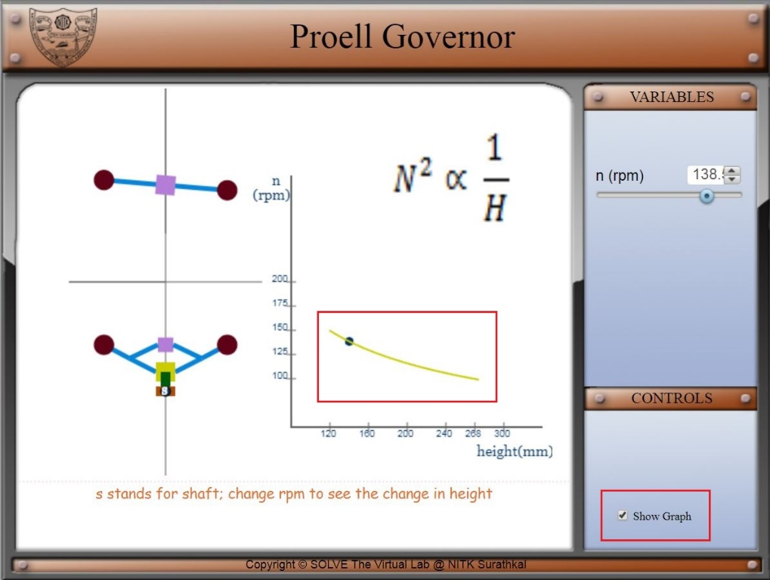

**QUIZ QUESTIONS**:

1) Which among these is a pendulum type governor

1. Inertia governor
2. Watt governor
3. Porter governor
4. Proell governor

2) Which component control "variation of speed each cycle of the engine"?

1. Governor
2. Flywheel
3. Accelerator
4. Carburettor

3) Lightest fly balls used among these in

1. Watt governor
2. Porter governor
3. Proell governor
4. Equal weight in all

4) Which one of the following is a Dead weight type governor?

1. Porter Governor
2. Hartnell Governor
3. Wilson-Hartnell Governor
4. Hartung Governor

5) The height of a governor is distance measure from

1. the centre of two balls mass
2. the centre of balls mass to the point of intersection of upper arms
3. the centre of balls mass to the point of intersection of  lower links
4. the point of intersection of upper arms to the point of intersection of  lower links

6)  Which of the following Governor is not suitable for High speeds

1. Watt
2. Hartnell
3. Wilson Hartnell
4. Hartong

7) The ratio of the height of porter governor (when the length of arms and links are equal) to the height of watt governor is (Where m is the mass of the ball and M is the mass of sleeve)

1. (m+M)/m
2. M/(m+M)
3. m/(m+M)
4. None of the above

8) Which type of governor is used in a petrol engine?

1. Pendulum type
2. Spring load type
3. Inertia type
4. Any of the above
5. SI engine doesn't have a governor

9) Governor is attached to the camshaft through

1. Bevel gear
2. Spur gear
3. Rack and pinion
4. Herringbone gear

10) Which of the following is more appropriate if we remove the governor :

1. The engine wouldn't work at all
2. We Can't control the speed limit
3. It will take more fuel for the same distance
4. None of these

**Assignment question:**

**Porter governor**

1) Derive the final equation of Porter governor?

2) Draw the full schematic working diagram of a centrifugal governor?

3) A Porter governor has equal arms each 250 mm long and pivoted on the axis of rotation. Each ball has a mass of 5 kg and the mass of the central load on the sleeve is 25 kg. The radius of rotation of the ball is 150 mm when the governor begins to lift and 200 mm when the governor is at maximum speed. Find the minimum and maximum speeds and range of speed of the governor. **ans154.5 rpm , range - N2-N1=154.5-133.8=20.7RPM**

**Proell governor**

* 1. Briefly classify the governors?
  2. Derive the final height equation of Proell governor?
  3. Write the advantages of Proell governor over portal governor?

**EXPLORE:**

1) Why don't we use governor in petrol engines?

2) Which is the technology that is replacing mechanical governor in a modern car?